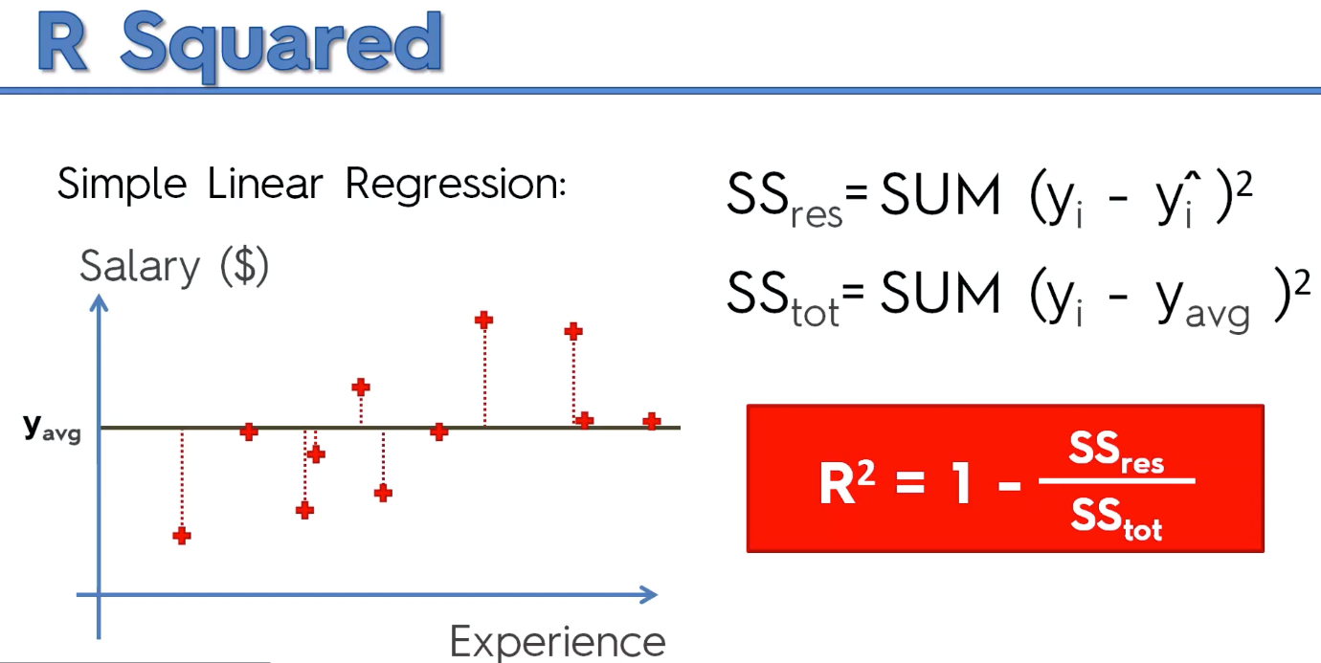R Squared Intuition

SSres – sum of squares of residuals

SStot – Sum of squares of total

R2 should be as close to 1 which is the Ideal Scenario

Adjusted R2 intuition

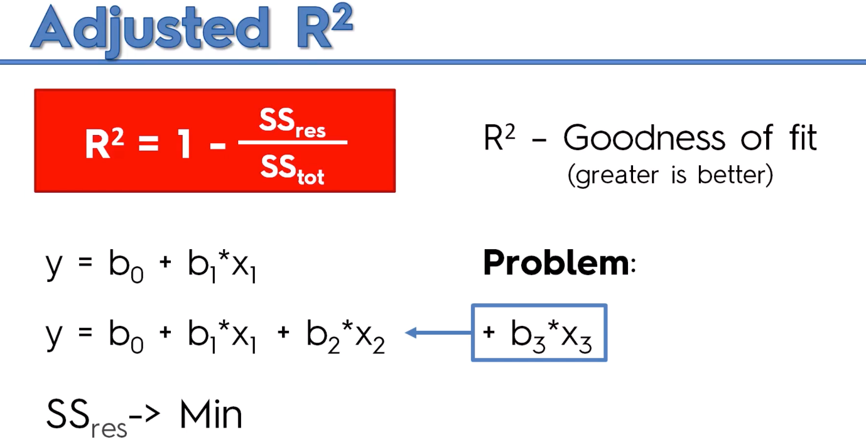If you add a variable to the model, we want to see if R square gets better or not.

R2 will never decrease if you add a new variable. It will always increase.

